**Trump has set economic growth on fire. Here is how he did it**

* President Donald Trump presides over an administration that has seen an enormous level of controversy that could overshadow a burgeoning economy.
* He has delivered on promises to cut taxes and regulations and promote activity through more aggressive government spending.
* Critics believe that it won't last because the fiscal stimulus is aimed only at near-term growth.
* The results, though, have been impressive: a surge in company profits and near-record levels of optimism from consumers and businesses.

CNBC.com - [Jeff Cox](https://www.cnbc.com/jeff-cox/) – September 8, 2018 CNBC.com

Link to Article - <https://www.cnbc.com/2018/09/07/how-trump-has-set-economic-growth-on-fire.html>

|  |  |  |  |  |  |  |  |  |  |  |  |  |  |  |  |  |  |  |  |  |  |  |  |
| --- | --- | --- | --- | --- | --- | --- | --- | --- | --- | --- | --- | --- | --- | --- | --- | --- | --- | --- | --- | --- | --- | --- | --- |
| |  |  |  | | --- | --- | --- | |  |  |  | | |  |  |  | | --- | --- | --- | |  |  |  | | |  |  |  | | --- | --- | --- | |  |  |  | | |  |  |  | | --- | --- | --- | |  |  |  | | |  |  |  | | --- | --- | --- | |  |  |  | | |  |  |  | | --- | --- | --- | |  |  |  | |

President [Donald Trump](https://www.cnbc.com/donald-trump/) is more than 19 months into an administration engulfed in so much controversy that it may overshadow a tremendous achievement, namely an economic boom uniquely his.

During his time in office, the economy has achieved feats most experts thought impossible. GDP is growing at a 3 percent-plus rate. The unemployment rate is near a 50-year low. Meanwhile, the stock market has jumped 27 percent amid a surge in corporate profits.

Friday brought another round of good news: Nonfarm payrolls rose by a better-than-expected 201,000 and wages, the last missing piece of the economic recovery, [increased by 2.9 percent year over year](https://www.cnbc.com/2018/09/07/us-nonfarm-payrolls-aug-2018.html) to the highest level since April 2009. That made it the best gain since the recession ended in June 2009.

His critics, a group that includes a legion of Wall Street economists, most Democrats and even some in his own Republican Party, don't believe it will last. They figure the current boom will begin petering out as soon as mid-2019 and possibly end in recession in 2020.

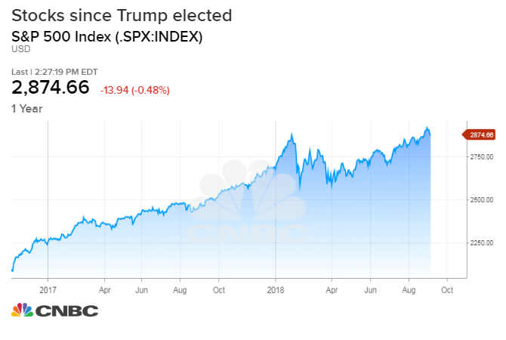

But even they acknowledge that the current numbers are a uniquely Trumpian achievement and not owed to policies already set in motion when he took office.

"I still believe the big story this year is an economic boom that most folks thought impossible," [Larry Kudlow](https://www.cnbc.com/id/105059765), director of the National Economic Council and a chief advisor to Trump, said in a recent interview with CNBC.com. "I understand that he's been in for a year and a half, but when you look at those numbers, this is not going away."

Indeed, the economy does seem to be on fire, and it's fairly easy to draw a straight line from Trump's policies to the current trends.

**Trump's economic achievements**

Business confidence is soaring, in part thanks to a softer regulatory environment. Consumer sentiment by one measure is at its highest level in 18 years. Corporate profits, owed in good part to last year's tax cuts, are coming close to setting records.

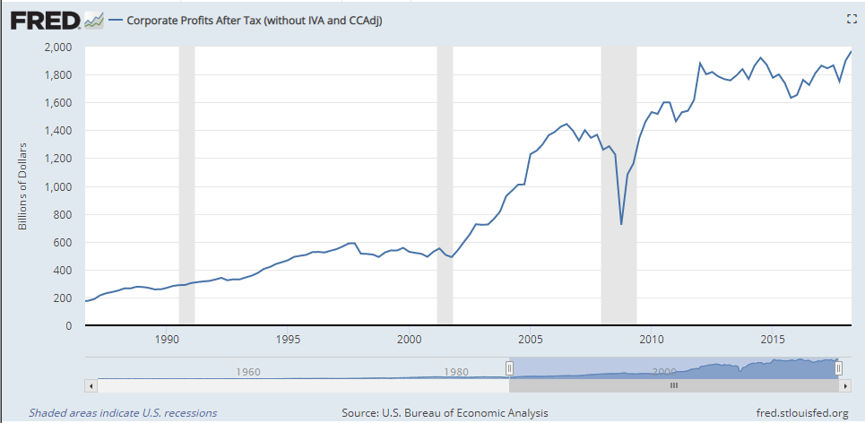

Each of those accomplishments can be tied either directly to new policies or at least indirectly through a brimming sense of hope from businesses that the White House is back on their side.

"When you look at those confidence indexes, they're telling you something," Kudlow said. "His attitude is, we're not punishing business, we're not punishing success, we want to make things easier to do business and to hire, and I think it's had a very positive effect and a very palpable effect."

GDP most recently gained 4.2 percent in the second quarter, the best performance in nearly four years. At the same time, the unemployment rate is 3.9 percent, just one-tenth of a percentage point above the lowest level since 1969.

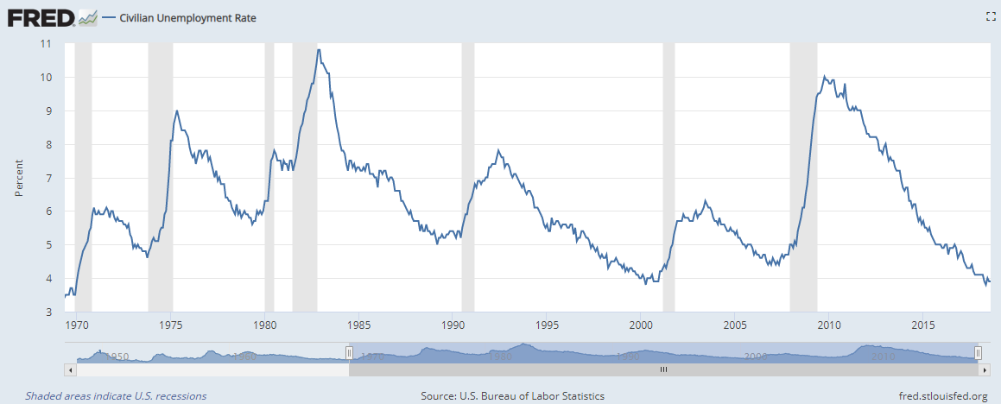

But there are some more telling figures about just how much progress has been made under Trump.

At a time when most economists had been using the term "full employment" to describe the economy, 3.9 million more Americans have joined the ranks of the working during the Trump term. During the same period under former President Barack Obama, employment had fallen by 2.6 million. The economy in total, while still not in breakout mode, has grown by $1.4 trillion through the second quarter under Trump; the same time period for Obama saw a gain of just $481 billion, or a third of Trump's total.

Businesses are investing, consumers are spending and innovation is on the rise as well.

Trump pledged that he would pare down regulations that were choking business activity. While the actual moves toward deregulation haven't been quite as ambitious as planned, the approach has won him converts in the business community.

The most recent reading from the National Federation of Independent Business was the second highest in history dating back 45 years. Small business owners reported aggressive hiring plans, the only obstacle to which has been a dearth of labor supply. The end of June saw 6.7 million job openings and just 6.6 million Americans classified as unemployed, an unprecedented imbalance.

"Expansion continues to be a priority for small businesses who show no signs of slowing as they anticipate more sales and better business conditions." NFIB President and CEO Juanita Duggan said in a statement.

**How he did it**

Trump's economic program was very simple: an attack on taxes and regulations with an extra dose of spending on infrastructure and the military that would create a supply shock to a moribund economy.

On the tax side, the White House pushed through a massive $1.5 trillion reform plan that sliced the highest-in-the-world corporate tax from 35 percent to 21 percent and lowered rates for millions of taxpayers, though the cuts for individuals will expire in 2025.

On deregulation, Trump ordered that rules be pared back or eliminated across the board. During his time in office, Congress has cut back on the [Dodd-Frank](https://www.cnbc.com/id/47075854) banking reforms, particularly in areas affecting regional and community institutions, rolled back a multitude of environmental protections that he said were killing jobs and took a hatchet to dozens of other rules. (The left-leaning Brookings Institution think tank has a rolling deregulation [tracker that can be viewed here](https://www.brookings.edu/interactives/tracking-deregulation-in-the-trump-era/).)

During the first year of his administration, "significant regulatory activity" had declined 74 percent from where it was in the same period of the Obama administration, according to data collected by Bridget Dooling, research professor at GW's Regulatory Studies Center.

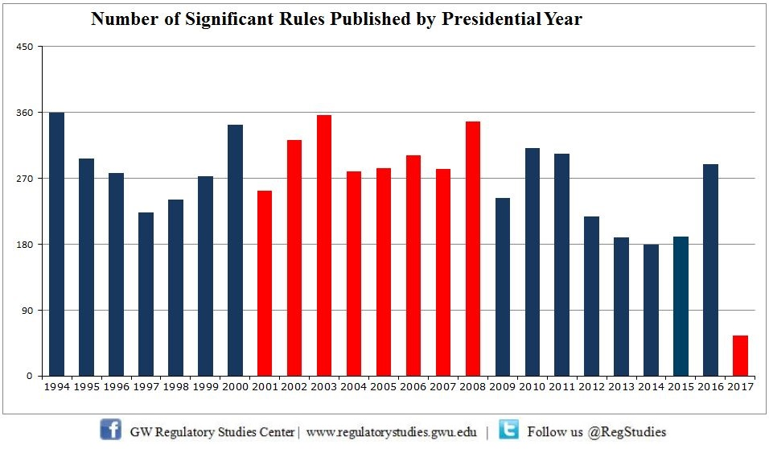

The Dodd-Frank rollbacks have been particularly helpful to community banks, whose share prices collectively are up more than 25 percent over the past year. Small-cap stocks in general have strongly outperformed the broader market, gaining 23 percent over the past 12 months at a time when the S&P 500 is up 17 percent.

The Federal Register, where business rules are stored and thus serves as a proxy for regulatory activity, was 19.2 percent smaller from Inauguration Day until Aug. 16 under Trump than during the same period for Obama.

"You can think of that as turning off the spigot of new regulations," Dooling said in an interview. She said more aggressive movement appears to be on the way.

Dooling said recent regulatory changes from the Environmental Protection Agency and the departments of Education and Labor will advance deregulation in an even "more meaningful way."

In addition to expected deregulation benefits, there's also anticipation that the true benefits of tax cuts have yet to kick in. [Mick Mulvaney, head of the Office of Management and Budget, recently told CNBC](https://www.cnbc.com/2018/07/27/trump-budget-director-says-gdp-jump-was-no-sugar-high.html) that he attributes the bulk of new economic growth to deregulation rather than the tax cuts, whose benefits he expects to come later.

"It's still too early to tell. We haven't seen any of the multipliers yet from tax reform," said Jacob Oubina, senior U.S. economist at RBC Capital Markets. "We have enough in terms of ammunition to put in 3 percent growth for the rest of this year and even all of 2019, but we haven't seen sort of this spike in activity yet."

There's been another interesting trend that is peculiar to the Trump economy: a drifting of benefits from urban centers to nonmetropolitan areas, which are seeing their first collective population growth since 2010.

Trump's tax cuts "should deliver greater tax relief to rural areas where there is a higher rate of small business owners who will benefit from the favorable pass-through tax rates," Joseph Song, U.S. economist at Bank of America Merrill Lynch, said in a recent note to clients.

**Skeptics doubt it will last**

His critics don't believe it will last. They figure the current boom will begin petering out as soon as mid-2019 and possibly end in recession in 2020.

"This is temporary. In fact it's raising the odds of recession on the other side," said Mark Zandi, chief economist at Moody's Analytics. "The economy is now more cyclical because of the stimulus. You're doing a lot of near-term growth, but you're setting up for a tough time on the other side of it. That's why most economists think we have a recession in 2020, because of these policies."

There is plenty to worry about: A ballooning debt that will only get worse if Trump's growth predictions don't materialize, the increasing likelihood of a trade war that sparks inflation and punishes U.S. companies that depend on exports, and a suddenly slowing real estate market that could be pointing to larger issues at the heart of the economy.

Indeed, while Trump has preached fiscal discipline, he has not practiced it. The U.S. economy is carrying a $45 trillion debt load that continues to grow under Trump. Government debt has swollen by $1.46 trillion in Trump's 19 months, an increase of 7.3 percent, to $21.4 trillion. The public owes $15.7 trillion of that debt, an increase of 9 percent.

**Government debt since 2009**

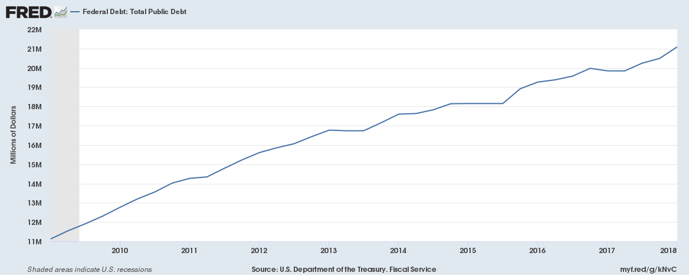

There also are some pockets of the economy that remain mired in slowness, most notably wage gains. Average hourly earnings have risen just 4.1 percent since January 2017 when Trump took office, barely keeping pace with inflation. (Still, during the same period wages rose just 3 percent under Obama.)

Then there's the Federal Reserve, which cut rates and flooded the financial system with cash during the Obama years. Now it is reversing course and tightening, or raising rates.

"The short answer is the honest answer: Nobody knows," Joe LaVorgna, chief economist for the Americas at Natixis, said in assessing the duration of the Trump bump. "If we generate 3.5 percent this year and generate 3.5 percent next year, that could happen provided the Fed doesn't kill it. Then you're going to say it looks like some of it was Trump. It has to be."

With midterm elections fast approaching, Trump's economic record will be front and center. The strong performance could bolster Republicans' hopes as the GOP tries to hold onto control of both the House and the Senate.

So far, though, the experts have gotten it wrong about Trump.

LaVorgna said the final verdict in assessing the Trump performance is yet to come.

When Obama took criticism for the performance during his years, he often blamed obstructionist Republicans.

If the economy falters now, Trump will have no one to blame but himself.

"It's very hard to disentangle all these effects," he said. "If we do get 3 percent growth, which we haven't had since 2005, you have to give credit where it's due. Whether it lasts, who knows?"

**The Reality of 3 Percent Growth**

The economy was strong through the first half of 2018, but few analysts see the good times continuing.

U.S. News and World Reports - [Andrew Soergel](https://www.usnews.com/topics/author/andrew-soergel) Senior Reporter - Aug. 31, 2018

Link to Article:

<https://www.usnews.com/news/the-report/articles/2018-08-31/the-reality-of-3-percent-economic-growth>

President Donald Trump rode into the White House on the backs of what many experts considered to be fairly lofty economic promises – chief among them the claim that he'd be able to jump-start a slow but steady economic recovery into a full-fledged boom.

While the president has at times speculated that he'll be able to get the U.S. into a groove that will see annual economic growth as high as 6 percent, for the most part he has set a much lower target of 3 percent.

And in his second year in office, it's looking like U.S. GDP is going to get awfully close to that benchmark.

The Bureau of Economic Analysis this week released revised growth estimates for the second quarter, showing that the U.S. economy expanded at a 4.2 percent clip during April, May and June. That's the strongest quarterly rate of expansion America has seen since mid-2014.

And following the 2.2 percent rate the economy maintained through the first three months of the year, 2018 has started off on a strong note for a president hoping for as much good economic news as possible in the midst of a wide-ranging series of trade conflicts and ahead of what's expected to be contentious 2018 midterm elections.

Mike Loewengart, vice president of investment strategy at E-Trade Financial Corporation, wrote in a note Wednesday that "anything near 4 percent should be viewed favorably," suggesting the report "should also serve as another lesson to shelf geopolitical noise and focus on the fundamentals, which are nothing if not strong."

"Some say we're late in the business cycle, but clearly there's more gas in the tank at least for now," he said.

"We're late in the business cycle, but clearly there's more gas in the tank at least for now."

But "for now" is the phrase that several analysts were weighing this week. The U.S. is currently in the midst of its second-longest economic expansion, and few would argue that the consistently strong employment reports, burgeoning signs of wage growth and continued consumer optimism point to anything less than stable footing for the economy.

Still, whether the good times stick around – and how long they remain – will likely play a considerable role in how the Trump administration's economic agenda is viewed over the course of history. Few expect the U.S. to enter a recession in the final months of 2018 and heading into 2019. But few also expect the economy will be able to maintain its current pace.

Trump has fought this characterization, boasting during an appearance at the White House last month – when the BEA initially reported the U.S. grew at a 4.1 percent clip during April, May and June – that "these economic numbers are very, very sustainable" and that "this isn't a one-time shot."

But Gus Faucher, a senior vice president and chief economist at The PNC Financial Services Group, described the economy this week as being in "good shape," though he warned that "growth of above 4 percent is unsustainable, and the economy is set to slow somewhat in the second half of 2018."

Scott Anderson, chief economist and executive vice president at Bank of the West Economics, made a similar assessment, writing in a research note that "the robust second quarter growth … is not likely to be sustained."

Few quibble with the accuracy of recent GDP reports, but much of the growth the U.S. has seen in recent months has been attributed to one-off factors that are likely to reverse course in the coming month – chief among them, trade dynamics that bolstered U.S. exports as companies rushed to ship products overseas before Trump's tariffs kicked in.

Net exports contributed nearly 1.2 percentage points to America's economic growth in the second quarter. In only one three-month window since the end of the Great Recession has trade played a greater role in supporting quarterly growth – meaning the last quarter's numbers could quickly turn around.

"Overall trade will be a drag on growth through the rest of this year," Faucher said this week, warning that "an escalation in current trade tensions is a significant downside risk for U.S. growth."

The U.S. has also benefited from an increase in spending among U.S. consumers, whose purchases contributed nearly 2.6 percentage points to GDP growth in the second quarter. Personal consumption expenditures were far and away the economy's most substantial support pillar in the second quarter.

And yet there's some reason to think consumer spending could cool off in the months ahead. Anderson warns that "while consumer spending has remained strong early in the third quarter, the housing market has weakened further, with home building rising less than expected in July and both new and existing home sales declining."

Housing is a particularly important sector to GDP growth in each quarter, with the National Association of Home Builders estimating housing investments and spending typically represent between 15 percent and 18 percent of America's economic growth in a given quarter. And in the second quarter, consumer spending on housing services accounted for nearly 12 percent of the country's expansion.

With lackluster home construction reports and housing availability already tight in many markets across the country, prices are only likely to rise on existing homes, potentially pricing homebuyers out of the market and stymieing economic growth over the long haul.

"On a year-ago basis, pending home sales (in July) decreased 2.3 percent, the seventh consecutive annual decline," Anderson wrote, describing housing's weakness as "broad-based" and projecting the economy will cool off to a growth rate of roughly 3 percent in the third quarter and 2.8 percent through the year.

An annual expansion of 2.8 percent – close to Trump's desired target – would still be the best economic growth the U.S. has seen since 2015. And if the economy's performance over the next few months exceeds expectations and year-over-year GDP growth lands right on 3 percent, 2018 will be remembered as the economy's strongest year for expansion since 2005.

It's fair to question how much credit Trump should be taking for an economic run that began in earnest under his predecessor – and, indeed, there's plenty of [debate](https://www.princeton.edu/~mwatson/papers/Presidents_Blinder_Watson_July2014.pdf) over the extent to which individual presidents are actually able to influence the economy's trajectory.

But most economists don't believe the good times seen in the second quarter of 2018 are indicative of what lies ahead for the U.S. The Federal Reserve is among several domestic and international institutions that have yet to meaningfully update its long-term economic projections in the aftermath of Trump's 2016 Election Day victory. Most recently, the Fed projected GDP growth would only hover between 1.8 percent and 2 percent over the long term.

And with America's central bank raising interest rates, the stimulative effects of last year's tax overhaul fading as the months and years go by and mounting concern over international relations and rising government debt, it may be too soon for the administration to get used to economic reports similar to those seen out of the second quarter.

Loewengart said next year is a "big question mark, and that's a time horizon investors should be thinking about."

He pointed to several warning signs that Wall Street may not be fully anticipating, including weakness in the housing sector and "ballooning government debt issuance that seemingly no one is talking about."

"Throw in midterm elections at the end of this year, and our economic picture could be quite different from what we're viewing today," he said.